Identity  (Mother, Daughter, Son …)  (Your roles in life)  I am a son  Partner to Claire  I have 2 sons Toby 5 and Nathan 10  I am a student at Hopwood hall college  I am a qualified engineer and a mechanic  I am a driver  I have my own car for work  Currently a PA for 2 young men  I have a clear DBS cert  I live in Newhey  Lee (42)  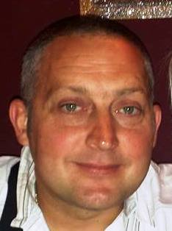 | Hobbies  (Please give detail, ie if you like reading,  what authors etc)  I am a motorbike fanatic and I own several  I enjoy maintaining and repairing them as well as going out for bike rides  My current bike is a Suki bandit  I enjoy dirt biking on my YZF250  I enjoy going to race meetings and biker gatherings at Riving ton Barn and Kirby Lonsdale  I have 2 dogs Holy and Betty and enjoy walking them  I am a keen Mountain Biker  I enjoy attending music gigs especially the artic monkeys  I enjoy socialising with my friends
Gifts  (What qualities do you think you have.  Ask people around you, family friends etc)  - Reliable  - Like to give 100%  - Punctual  - Caring  - Humerous  - Flexible  - committed  - Friendly  - Easy to get along with  - Positive upbeat personality  - honest | Skills  (What qualities do you think you have.  Ask people around you, family friends etc)  - I have great interpersonal skills  - Laid back and easy going  - Calm  - Not easily flustered  - Friendly  - Ability to diffuse a situation

